Business and Management

Paper One: Case Study Mock Examination Paper

BUSINESS AND MANAGEMENT
HIGHER LEVEL
PAPER 1

2 hours 15 minutes

___________________________________________________________________

INSTRUCTIONS to candidates

- Do not open this examination paper until instructed to do so.
- A clean copy of the Business and Management case study (LadyA) is required for this examination paper.
- Read the case study carefully.

HL candidates:

- Section A: answer two questions.
- Section B: answer the compulsory question.
- Section C: answer the compulsory question.
- A calculator is required for this examination paper.
- Clean copies of the Business and Management formulae sheet and discount tables are required for this examination paper.
- The maximum mark for this examination paper is [80 marks].

Business and Management

Paper One: Case Study Mock Examination Paper

BUSINESS AND MANAGEMENT
STANDARD LEVEL
PAPER 1

1 hour 15 minutes

___________________________________________________________________

INSTRUCTIONS to candidates

- Do not open this examination paper until instructed to do so.
- A clean copy of the Business and Management case study (LadyA) is required for this examination paper.
- Read the case study carefully.

SL candidates:

- Section A: answer two questions.
- Section B: answer the compulsory question.
- A calculator is required for this examination paper.
- Clean copies of the Business and Management formulae sheet are required for this examination paper.
- The maximum mark for this examination paper is [50 marks].

SECTION A

Answer two questions from this section.

1. (a) Define the following terms:

(i) sole trader (line 5) [2 marks]

(ii) revenue (line 73). [2 marks]

(b) With reference to LadyA, distinguish between autocratic and laissez-faire
leadership styles. [4 marks]

(c) Analyse the marketing techniques of charitable organisations and compare
these to profit making organisations, like LadyA Management Limited. [7 marks]

2. (a) Using a SWOT analysis framework for LadyA Management Limited, identify
two current weaknesses and two current threats. [4 marks]

(b) Explain two reasons why LadyA decided to set up a private limited company. [4 marks]

(c) Analyse the usefulness of market segmentation and consumer profiles, if
LadyA decides to widen her product portfolio and distribute to a global market
(option 2). [7 marks]

3. (a) Define the following terms:

- focus group (line 64) [2 marks]

(ii) fringe benefits (line 13). [2 marks]

(b) With reference to LadyA, distinguish between above-the-line and
below-the-line promotion. [4 marks]

(c) Using a PESTLE analysis, examine the impact of the external environment on
the operations and profitability of LadyA Management Limited. [7 marks]

SECTION B

Answer the compulsory question from this section.

4. (a) Outline one advantage and one disadvantage of ethical marketing. [4 marks]

(b) Explain one function of the human resources department in the successful
operation of LadyA Management Limited. [2 marks]

(c) Construct an organisation chart for LadyA Management Limited after its 2011
reorganisation and describe the nature of its organisation. [6 marks]

(d) Evaluate the value of primary and secondary research methods in
deciding between the strategic options identified by Kersey & Joyce. [8 marks]

SECTION C

Answer the compulsory question from this section.

5. After reading Kersey & Joyce’s report, Alejandra initially favoured option 3 saying she was being realistic about her age. However, Rafaele believed Alejandra still had several years left ‘at the top’ of the music business, and supported option 1 or 2. He argued charities need funding and suggested setting up the LadyA Children’s Foundation, pledging 20% of LadyA Management Limited’s profits to support its ‘good causes’. In the longer-term, by following option 1 or 2, she could:
- Maximise her revenue potential
- Become more commercially attractive to the South American market
- Become an celebrity ‘ambassador’ for a charity and support more non-profit activities

Persuaded by Rafaele’s passionate arguments, Alejandra asked Kersey & Joyce to prepare strategic plans and a decision tree for options 1 and 2. These were presented to Alejandra in March 2015.

Key recommendations – LadyA Management Limited should:
- Produce the perfume and cosmetic range, and any new products, in the U.S. using a joint venture with its current U.S. distribution company, so sharing the costs of the investment.
- Raise additional finance using the U.S. online crowdfunding* platform Kickstarter.
- Build a U.S. factory in a district where Hispanic unemployment is high.

Option 2 only:
- Use only online sales outside the United States, through a dedicated LadyA website, with promotions using social media, such as Facebook and Twitter.
- Outsource distribution to the global logistics company ‘World Facing Inc’.

Although understanding the brand advantages of reshoring** production to the U.S., Rafaele maintained that any additional production should also be outsourced to Malaysia, fearing that the investment required to set up a U.S. production facility might lead to future cash flow problems.

(a) Using Ansoff’s matrix, classify option 1 (line 139) and option3 (line 153). [2 marks]

(b) (i) Using the decision tree (item 1), calculate the expected values for options
1 and 2, using only the three-year net profit after interest and tax totals. [4 marks]

(ii) Compare and contrast the timings, size and probabilities of the financial
outcomes for options 1 and 2. [3 marks]

(c) Using information from the case study and item 2, analyse the arguments for
and against outsourcing manufacture of a new product range to Malaysia. [9 marks]

(d) Using information from the case study and items 1 to 5, and applying suitable
business tools, evaluate the strengths and weaknesses of options 1 and 2 and
make a supported recommendation to LadyA on which to select. [12 marks]

*Crowdfunding: the practice of funding a project or venture by raising many small amounts of money from a large number of people, typically via the Internet.
**Reshoring is the practice of bringing outsourced personnel and services back to the location, from which they were originally offshored.
Additional Information

Item 1: Decision tree information for Options 1 and 2 (figures in $ millions)
The information in the tables on the right of the decision tree represent the three financial outcomes (success, satisfactory, failure) for each option for the first three years of operation.
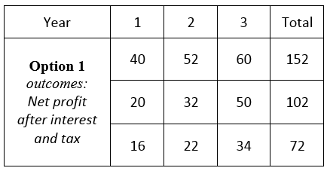
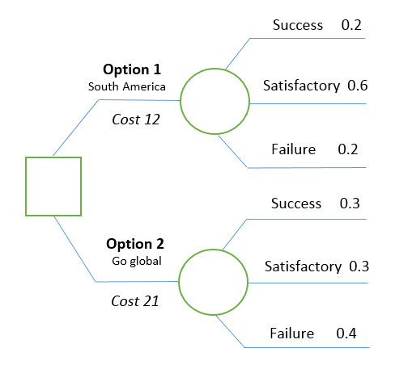

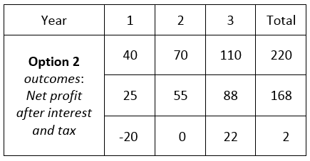

Item 2: Make or Buy decision
Rafaele asked LadyA Management Limited’s financial accountant to investigate the relative costs of buying in LadyA perfumes compared to manufacturing them in the proposed U.S. factory. The accountant produced preliminary findings for one perfume line to be used for initial comparison.
LadyA Eau de Parfum (Perfume spray) 50ml:
Forecast annual sales: 100,000 bottles
Cost-to-buy: $10 per bottle
Cost-to-make:
- Fixed costs: $700,000
- Variable cost per bottle: $4.50
The accountant points out that at sales volumes over 150,000 bottles, the variable cost per bottle is likely to fall by approximately $1 per bottle.

Item 3: The U.S. Hispanic market – Key Facts
The Hispanic market in the U.S. represents a huge opportunity for brands. The Hispanic population:
- Represents one sixth of all US residents - over 52 million Americans
- By 2020 it is projected to reach 66.3 million (53% of the total US population growth)
- Is relatively young (33.9% under the age of 18 compared to 20.1% of non-Hispanic)
- Tends to live in large urban areas, predominantly in California, Texas Florida and New York
Source: US Census

U.S. Hispanics are significant adopters of smart-phone, mobile and digital technology. Hispanics:
- Represented 11% of total e-commerce purchases in 2012
- Are more likely to purchase from mobile phones and tablets (24%) than non-Hispanics (10%)
- Typically use search engines for retail information (53%)
- Spend more time online than watching TV
- Are more receptive to digital advertising (41%) than non-Hispanics (37%)
- Spend more on clothes (89%) than the non-Hispanic population (86%)

Sources: US Hispanic retail report
Comscorc Hispanic digital consumer study, 2012

Item 4: Asia-Pacific leapfrogs North America to become world's largest regional ecommerce market
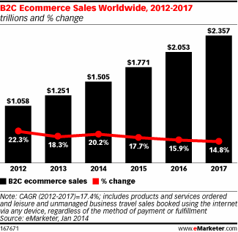
According to latest forecasts, worldwide business-to-consumer (B2C) ecommerce sales increased by 20.1% in 2014 reach $1.500 trillion. Growth came from the rapidly expanding online and mobile user based in emerging markets, and the push into new international markets by major brands.
In 2014, Asia-Pacific consumers spent more on ecommerce purchases than those in North America, reaching $525.2 billion compared with $482.6 billion in North America. China took more than 6 of every 10 dollars spent in Asia-Pacific. Gains in China, as well as in India and Indonesia, will push Asia-Pacific’s growth ahead. These countries, along with Argentina, Mexico, Brazil, Russia, Italy and Canada, will drive ecommerce sales growth worldwide.

Item 5: Music sales and revenues (2014)
Global revenue from recorded music totalled $15 billion in 2014, but the recorded music business shrunk by half from its peak of $40 billion in 1999 Revenues slipped 4% overall and even digital downloads, dominated by Apple’s iTunes, fell by 2.1% - the first time they have ever seen a decline. Factoring in CD sales, which have been plunging for over a decade, overall music sales in most of the world held steady, except for Japan which experienced steep drops in both physical and digital sales.
Artists incomes from recorded music have fallen over the last decade, as have revenues from other revenue streams, such as royalties from videos shown on television channels. However, revenues from touring have increased, bolstered by merchandising sales and appearance fees.
Source: International Federation for the Phonographic Industry – IFPI

